Experiment 3: Word Count using MapReduce
Experiment No. | 3 | Student | Jakkubabitha

Aim
To implement and execute the classic Word Count MapReduce program on Hadoop to count the frequency of each word in a given text file stored on HDFS.

Software Required
- Apache Hadoop 3.5.0 with MapReduce
- Hadoop streaming JAR / hadoop-mapreduce-examples JAR
- OpenJDK 17, macOS Terminal
Procedure
- Create a multi-sentence input file locally:
echo "Hadoop is Big Data. Big Data is used for decision making." > input.txt
echo "Hadoop processes large datasets efficiently across multiple nodes." >> input.txt
- Create an HDFS input directory and upload the file:
hdfs dfs -mkdir /input
hdfs dfs -put input.txt /input
- Run the built-in Word Count MapReduce job:
hadoop jar $HADOOP_HOME/share/hadoop/mapreduce/hadoop-mapreduce-examples-3.5.0.jar wordcount /input /output
- View the output:
hdfs dfs -cat /output/part-r-00000

Output
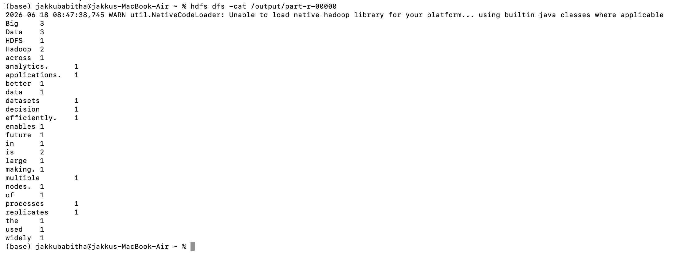
Fig 2: Word count output showing each word and its frequency from the input text

Result
The MapReduce Word Count job completed successfully. Words such as 'Big' (3), 'Data' (3), 'Hadoop' (2), 'is' (2) were counted correctly, with output written to /output/part-r-00000 on HDFS.
Conclusion
The Word Count MapReduce program was successfully executed on Hadoop. This experiment demonstrates the Map (tokenise and emit word,1) and Reduce (aggregate counts) paradigm, confirming Hadoop's ability to process and analyse text data in a distributed manner.

